

Final project

Submitted By Ijlal Ahmad
Submitted To Ms. Saira Kishwar
Roll No FL-21565
Date 23-05-2025
Subject Web Engneering

- Introduction
Welcome to [Car Showroom] - Your Ultimate Automotive Destination!

About Our Website
Our car showroom website is designed to provide a seamless digital experience for car enthusiasts and potential buyers. With five main sections, we offer comprehensive information about our inventory and services:
- Home - Your gateway to our premium collection of vehicles, featuring latest arrivals and special offers
- Cars - Browse our extensive inventory of new and pre-owned vehicles with detailed specifications
- Services - Discover our value-added services including financing, maintenance, and customization
- About - Learn about our company history, values, and what makes us different
- Contact - Easy ways to reach our sales team or visit our physical showroom

Key Features
- User-Friendly Interface: Intuitive navigation to help you find your dream car quickly
- High-Quality Visuals: Stunning images and videos showcasing our vehicle collection
- Comprehensive Information: Detailed specs, pricing, and features for every model
- Responsive Design: Accessible on all devices from desktops to smartphones.

Code
Index.html
<!DOCTYPE html>
<html lang="en">
<head>
<meta charset="UTF-8">
<meta name="viewport" content="width=device-width, initial-scale=1.0">
<title>Premium Motors - Home</title>
<link rel="stylesheet" href="style.css">
</head>
<body>
<header class="header">
<nav class="navbar">
<div class="logo">Premium Motors</div>
<div class="nav-links">
<a href="index.html">Home</a>
<a href="cars.html">Cars</a>
<a href="services.html">Services</a>
<a href="about.html">About</a>
<a href="contact.html">Contact</a>
</div>
</nav>
</header>

<section class="hero">
<div class="hero-content">
<h1>Experience Luxury Driving</h1>
<p>Discover our premium collection of luxury vehicles</p>
<button class="btn">Explore Inventory</button>
</div>
</section>

<section class="featured-cars">
<h2>Featured Vehicles</h2>
<div class="grid">
<div class="card">
<img src="images/car1.jpg" alt="Luxury Car">
<div class="card-content">
<h3>2023 Mercedes-Benz S-Class</h3>
<p>Experience ultimate luxury and cutting-edge technology</p>
<button class="btn">Learn More</button>
</div>
</div>
<div class="card">
<img src="images/car2.jpg" alt="Luxury Car">
<div class="card-content">
<h3>Porsche 911 RP</h3>
<p>Experience ultimate luxury and cutting-edge technology</p>
<button class="btn">Learn More</button>
</div>
</div>
<div class="card">
<img src="images/car3.jpg" alt="Luxury Car">
<div class="card-content">
<h3>2024 Range Rover</h3>
<p>Experience ultimate luxury and cutting-edge technology</p>
<button class="btn">Learn More</button>
</div>
</div>
<!-- Add more car cards -->
</div>
</section>

<footer class="footer">
<div class="footer-content">
<div class="footer-section">
<h4>Quick Links</h4>
<ul>
<li><a href="index.html">Home</a></li>
<li><a href="about.html">About Us</a></li>
<li><a href="contact.html">Contact</a></li>
</ul>
</div>
<div class="footer-section">
<h4>Contact Info</h4>
<p>123 Premium Avenue</p>
<p>contact@premiummotors.com</p>
<p>(555) 123-4567</p>
</div>
<div class="footer-section">
<h4>Follow Us</h4>
<!-- Add social media links -->
</div>
</div>
</footer>

<script src="script.js"></script>
</body>
</html>

Cars.html
<!DOCTYPE html>
<html lang="en">
<head>
<meta charset="UTF-8" />
<meta name="viewport" content="width=device-width, initial-scale=1.0" />
<title>Premium Motors - Inventory</title>
<link rel="stylesheet" href="style.css" />
</head>
<body>
<header class="header">
<nav class="navbar">
<div class="logo">Premium Motors</div>
<div class="nav-links">
<a href="index.html">Home</a>
<a href="cars.html">Cars</a>
<a href="services.html">Services</a>
<a href="about.html">About</a>
<a href="contact.html">Contact</a>
</div>
</nav>
</header>

<section class="hero inventory-hero">
<div class="hero-content">
<h1>Our Premium Collection</h1>
<p>Explore our curated selection of luxury vehicles</p>
</div>
</section>

<section class="featured-cars">
<div class="filter-section">
<select id="price-filter">
<option value="all">Price Range</option>
<option value="0-50000">$0 - $50,000</option>
<option value="50000-100000">$50,000 - $100,000</option>
<option value="100000+">$100,000+</option>
</select>
<select id="type-filter">
<option value="all">Vehicle Type</option>
<option value="suv">SUV</option>
<option value="sedan">Sedan</option>
<option value="sports">Sports</option>
</select>
</div>

<div class="grid">
<!-- BMW Card -->
<div class="card">
<img
src="https://images.unsplash.com/photo-1555215695-3004980ad54e"
alt="BMW 7 Series"
/>
<div class="card-content">
<h3>2024 BMW 7 Series</h3>
<div class="car-specs">
<p><strong>Price:</strong> $94,300</p>
<p><strong>Mileage:</strong> 15,000 mi</p>
<p><strong>Engine:</strong> 3.0L Turbo I6</p>
</div>
<button class="btn">Schedule Test Drive</button>
</div>
</div>

<!-- Mercedes-Benz Card -->
<div class="card">
<img
src="https://images.unsplash.com/photo-1553440569-bcc63803a83d"
alt="Mercedes S-Class"
/>
<div class="card-content">
<h3>2024 Mercedes-Benz S-Class</h3>
<div class="car-specs">
<p><strong>Price:</strong> $118,450</p>
<p><strong>Mileage:</strong> 8,500 mi</p>
<p><strong>Engine:</strong> 4.0L V8 Biturbo</p>
</div>
<button class="btn">Schedule Test Drive</button>
</div>
</div>

<!-- Porsche Card -->
<div class="card">
<img
src="https://images.unsplash.com/photo-1583121274602-3e2820c69888"
alt="Porsche 911"
/>
<div class="card-content">
<h3>2024 Porsche 911 Turbo S</h3>
<div class="car-specs">
<p><strong>Price:</strong> $215,000</p>
<p><strong>Mileage:</strong> 3,200 mi</p>
<p><strong>Engine:</strong> 3.8L Twin-Turbo H6</p>
</div>
<button class="btn">Schedule Test Drive</button>
</div>
</div>

<!-- Ferrari Card -->
<div class="card">
<img
src="https://images.unsplash.com/photo-1618843479313-40f8afb4b4d8"
alt="Ferrari Roma"
/>
<div class="card-content">
<h3>2024 Ferrari Roma</h3>
<div class="car-specs">
<p><strong>Price:</strong> $247,000</p>
<p><strong>Mileage:</strong> 1,500 mi</p>
<p><strong>Engine:</strong> 3.9L Twin-Turbo V8</p>
</div>
<button class="btn">Schedule Test Drive</button>
</div>
</div>
</div>
</section>

<footer class="footer">
<div class="footer-content">
<div class="footer-section">
<h4>Quick Links</h4>
<ul>
<li><a href="index.html">Home</a></li>
<li><a href="about.html">About Us</a></li>
<li><a href="contact.html">Contact</a></li>
</ul>
</div>
<div class="footer-section">
<h4>Contact Info</h4>
<p>123 Premium Avenue</p>
<p>contact@premiummotors.com</p>
<p>(555) 123-4567</p>
</div>
<div class="footer-section">
<h4>Follow Us</h4>
<!-- Add social media links -->
</div>
</div>
</footer>

<script src="script.js"></script>
</body>
</html>

Services.html
<!DOCTYPE html>
<html lang="en">
<head>
<meta charset="UTF-8">
<meta name="viewport" content="width=device-width, initial-scale=1.0">
<title>Premium Motors - Services</title>
<link rel="stylesheet" href="style.css">
</head>
<body>
<header class="header">
<nav class="navbar">
<div class="logo">Premium Motors</div>
<div class="nav-links">
<a href="index.html">Home</a>
<a href="cars.html">Cars</a>
<a href="services.html">Services</a>
<a href="about.html">About</a>
<a href="contact.html">Contact</a>
</div>
</nav>
</header>

<section class="hero services-hero">
<div class="hero-content">
<h1>Premium Services</h1>
<p>Comprehensive care for your luxury vehicle</p>
</div>
</section>

<section class="services">
<div class="grid">
<div class="card service-card">
<img src="https://images.unsplash.com/photo-1580273916550-e323be2ae537" alt="Financing">
<div class="card-content">
<h3>Financing Solutions</h3>
<p>Flexible payment plans and competitive rates</p>
<ul class="service-list">
<li>Lease Options</li>
<li>Loan Approvals</li>
<li>Credit Assistance</li>
</ul>
</div>
</div>

<div class="card service-card">
<img src="https://images.unsplash.com/photo-1568605117036-5fe5e7bab0b7" alt="Maintenance">
<div class="card-content">
<h3>Expert Maintenance</h3>
<p>Factory-trained technicians using genuine parts</p>
<ul class="service-list">
<li>Regular Servicing</li>
<li>Warranty Coverage</li>
<li>Diagnostic Checks</li>
</ul>
</div>
</div>
<!-- Add more service cards -->
</div>
</section>

<section class="additional-services">
<h2>Additional Benefits</h2>
<div class="grid">
<div class="benefit-card">
<h3>24/7 Roadside Assistance</h3>
<p>Comprehensive coverage for peace of mind</p>
</div>
<div class="benefit-card">
<h3>Vehicle Customization</h3>
<p>Personalize your vehicle to your taste</p>
</div>
</div>
</section>

<footer class="footer">
<div class="footer-content">
<div class="footer-section">
<h4>Quick Links</h4>
<ul>
<li><a href="index.html">Home</a></li>
<li><a href="about.html">About Us</a></li>
<li><a href="contact.html">Contact</a></li>
</ul>
</div>
<div class="footer-section">
<h4>Contact Info</h4>
<p>123 Premium Avenue</p>
<p>contact@premiummotors.com</p>
<p>(555) 123-4567</p>
</div>
<div class="footer-section">
<h4>Follow Us</h4>
<!-- Add social media links -->
</div>
</div>
</footer>

<script src="script.js"></script>
</body>
</html>

Contact.html
<!DOCTYPE html>
<html lang="en">
<head>
<meta charset="UTF-8">
<meta name="viewport" content="width=device-width, initial-scale=1.0">
<title>Premium Motors - Contact</title>
<link rel="stylesheet" href="style.css">
</head>
<body>
<header class="header">
<nav class="navbar">
<div class="logo">Premium Motors</div>
<div class="nav-links">
<a href="index.html">Home</a>
<a href="cars.html">Cars</a>
<a href="services.html">Services</a>
<a href="about.html">About</a>
<a href="contact.html">Contact</a>
</div>
</nav>
</header>

<section class="hero contact-hero">
<div class="hero-content">
<h1>Connect With Us</h1>
<p>We're here to answer your questions</p>
</div>
</section>

<section class="contact-section">
<div class="contact-container">
<div class="contact-info">
<h2>Visit Our Showroom</h2>
<div class="info-card">
<h3>Address</h3>
<p>123 Luxury Avenue<br>Beverly Hills, CA 90210</p>
</div>
<div class="info-card">
<h3>Contact</h3>
<p>Phone: (555) 123-4567<br>Email: contact@premiummotors.com</p>
</div>
<div class="info-card">
<h3>Hours</h3>
<p>Mon-Fri: 9AM - 7PM<br>Sat: 10AM - 5PM<br>Sun: Closed</p>
</div>
</div>

<form class="contact-form">
<div class="form-group">
<input type="text" placeholder="Name" required>
</div>
<div class="form-group">
<input type="email" placeholder="Email" required>
</div>
<div class="form-group">
<input type="tel" placeholder="Phone">
</div>
<div class="form-group">
<textarea placeholder="Message" rows="5" required></textarea>
</div>
<button type="submit" class="btn">Send Message</button>
</form>
</div>

<div class="map-container">
<iframe src="https://www.google.com/maps/embed?pb=!1m18!1m12!1m3!1d3304.453260824987!2d-118.40658468478407!3d34.08379132343814!2m3!1f0!2f0!3f0!3m2!1i1024!2i768!4f13.1!3m3!1m2!1s0x80c2bc04d6d147a1%3A0xd6c7c379b84377f8!2sBeverly%20Hills%2C%20CA%2090210%2C%20USA!5e0!3m2!1sen!2suk!4v1623930407892!5m2!1sen!2suk"
width="100%" height="450" style="border:0;" allowfullscreen="" loading="lazy"></iframe>
</div>
</section>

<footer class="footer">
<div class="footer-content">
<div class="footer-section">
<h4>Quick Links</h4>
<ul>
<li><a href="index.html">Home</a></li>
<li><a href="about.html">About Us</a></li>
<li><a href="contact.html">Contact</a></li>
</ul>
</div>
<div class="footer-section">
<h4>Contact Info</h4>
<p>123 Premium Avenue</p>
<p>contact@premiummotors.com</p>
<p>(555) 123-4567</p>
</div>
<div class="footer-section">
<h4>Follow Us</h4>
<!-- Add social media links -->
</div>
</div>
</footer>

<script src="script.js"></script>
</body>
</html>

About.html
<!DOCTYPE html>
<html lang="en">
<head>
<meta charset="UTF-8">
<meta name="viewport" content="width=device-width, initial-scale=1.0">
<title>Premium Motors - About Us</title>
<link rel="stylesheet" href="style.css">
</head>
<body>
<header class="header">
<nav class="navbar">
<div class="logo">Premium Motors</div>
<div class="nav-links">
<a href="index.html">Home</a>
<a href="cars.html">Cars</a>
<a href="services.html">Services</a>
<a href="about.html">About</a>
<a href="contact.html">Contact</a>
</div>
</nav>
</header>

<section class="hero about-hero">
<div class="hero-content">
<h1>Our Legacy of Excellence</h1>
<p>Over three decades of luxury automotive experience</p>
</div>
</section>

<section class="about-content">
<div class="history">
<h2>Our Story</h2>
<p>Founded in 1990, Premium Motors has established itself as a leader in the luxury automotive industry...</p>
<div class="milestones">
<div class="milestone-card">
<h3>5000+</h3>
<p>Vehicles Delivered</p>
</div>
<div class="milestone-card">
<h3>98%</h3>
<p>Customer Satisfaction</p>
</div>
</div>
</div>

<div class="team">
<h2>Leadership Team</h2>
<div class="grid">
<div class="card team-card">
<img src="https://images.unsplash.com/photo-1560250097-0b93528c311a" alt="CEO">
<div class="card-content">
<h3>John Anderson</h3>
<p>CEO & Founder</p>
</div>
</div>
<!-- Add more team members -->
</div>
</div>
</section>

<footer class="footer">
<div class="footer-content">
<div class="footer-section">
<h4>Quick Links</h4>
<ul>
<li><a href="index.html">Home</a></li>
<li><a href="about.html">About Us</a></li>
<li><a href="contact.html">Contact</a></li>
</ul>
</div>
<div class="footer-section">
<h4>Contact Info</h4>
<p>123 Premium Avenue</p>
<p>contact@premiummotors.com</p>
<p>(555) 123-4567</p>
</div>
<div class="footer-section">
<h4>Follow Us</h4>
<!-- Add social media links -->
</div>
</div>
</footer>

<script src="script.js"></script>
</body>
</html>

Style.css
:root {
--primary: #2c3e50;
--secondary: #e74c3c;
--light: #ecf0f1;
--dark: #34495e;
}

* {
margin: 0;
padding: 0;
box-sizing: border-box;
font-family: 'Segoe UI', sans-serif;
}

body {
line-height: 1.6;
background-color: var(--light);
}

.header {
background: var(--primary);
padding: 1rem;
position: fixed;
width: 100%;
top: 0;
z-index: 1000;
}

.navbar {
display: flex;
justify-content: space-between;
align-items: center;
max-width: 1200px;
margin: 0 auto;
}

.logo {
color: white;
font-size: 2rem;
font-weight: bold;
}

.nav-links {
display: flex;
gap: 2rem;
}

.nav-links a {
color: white;
text-decoration: none;
transition: color 0.3s;
}

.nav-links a:hover {
color: var(--secondary);
}

.hero {
height: 100vh;
background: linear-gradient(rgba(0,0,0,0.5), rgba(0,0,0,0.5)),
url('https://images.unsplash.com/photo-1485291571150-772bcfc10da5') center/cover;
display: flex;
align-items: center;
justify-content: center;
text-align: center;
color: white;
margin-top: 60px;
}

.hero-content h1 {
font-size: 4rem;
margin-bottom: 1rem;
}

.btn {
padding: 1rem 2rem;
background: var(--secondary);
color: white;
border: none;
border-radius: 5px;
cursor: pointer;
transition: transform 0.3s;
}

.btn:hover {
transform: translateY(-3px);
}

.featured-cars {
padding: 4rem 2rem;
max-width: 1200px;
margin: 0 auto;
}

.grid {
display: grid;
grid-template-columns: repeat(auto-fit, minmax(300px, 1fr));
gap: 2rem;
margin-top: 2rem;
}

.card {
background: white;
border-radius: 10px;
overflow: hidden;
box-shadow: 0 3px 10px rgba(0,0,0,0.1);
}

.card img {
width: 100%;
height: 200px;
object-fit: cover;
}

.card-content {
padding: 1.5rem;
}

.footer {
background: var(--dark);
color: white;
padding: 3rem 2rem;
margin-top: 4rem;
}

.footer-content {
max-width: 1200px;
margin: 0 auto;
display: grid;
grid-template-columns: repeat(auto-fit, minmax(250px, 1fr));
gap: 2rem;
}

/* Additional Styles for New Pages */
.inventory-hero {
background-image: linear-gradient(rgba(0,0,0,0.5), rgba(0,0,0,0.5)),
url('https://images.unsplash.com/photo-1494976388901-8329f2ec5c80');
}

.services-hero {
background-image: linear-gradient(rgba(0,0,0,0.5), rgba(0,0,0,0.5)),
url('https://images.unsplash.com/photo-1503376780353-7e6692767b70');
}

.about-hero {
background-image: linear-gradient(rgba(0,0,0,0.5), rgba(0,0,0,0.5)),
url('https://images.unsplash.com/photo-1553440569-bcc63803a83d');
}

.contact-hero {
background-image: linear-gradient(rgba(0,0,0,0.5), rgba(0,0,0,0.5)),
url('https://images.unsplash.com/photo-1485827404703-89b55fcc595e');
}

.contact-container {
max-width: 1200px;
margin: 2rem auto;
display: grid;
grid-template-columns: 1fr 2fr;
gap: 3rem;
padding: 2rem;
}

.contact-form {
display: flex;
flex-direction: column;
gap: 1rem;
}

.form-group input,
.form-group textarea {
width: 100%;
padding: 0.8rem;
border: 1px solid #ddd;
border-radius: 4px;
}

.milestones {
display: flex;
justify-content: center;
gap: 2rem;
margin: 2rem 0;
}

.milestone-card {
background: white;
padding: 2rem;
border-radius: 10px;
text-align: center;
box-shadow: 0 3px 10px rgba(0,0,0,0.1);
}

.service-list {
list-style: none;
margin: 1rem 0;
}

.service-list li {
padding: 0.5rem 0;
border-bottom: 1px solid #eee;
}

.filter-section {
display: flex;
gap: 1rem;
margin: 2rem 0;
justify-content: center;
}

.filter-section select {
padding: 0.5rem 1rem;
border-radius: 5px;
border: 1px solid var(--dark);
}

.car-specs {
margin: 1rem 0;
padding: 1rem;
background: var(--light);
border-radius: 5px;
}

/* Add media queries for responsiveness */
@media (max-width: 768px) {
.nav-links {
display: none;
}

.mobile-menu {
display: block;
}

.hero-content h1 {
font-size: 2.5rem;
}
}

Script.js
document.addEventListener('DOMContentLoaded', function() {
// Mobile menu toggle
const mobileMenu = document.createElement('div');
mobileMenu.className = 'mobile-menu';
mobileMenu.innerHTML = '☰';
document.querySelector('.navbar').appendChild(mobileMenu);

mobileMenu.addEventListener('click', function() {
document.querySelector('.nav-links').classList.toggle('active');
});

// Smooth scroll
document.querySelectorAll('a[href^="#"]').forEach(anchor => {
anchor.addEventListener('click', function(e) {
e.preventDefault();
document.querySelector(this.getAttribute('href')).scrollIntoView({
behavior: 'smooth'
});
});
});

// Active page indicator
const currentPage = location.pathname.split('/').pop();
document.querySelectorAll('.nav-links a').forEach(link => {
if (link.getAttribute('href') === currentPage) {
link.classList.add('active');
}
});
});

// Contact form handling
if (document.querySelector('.contact-form')) {
document.querySelector('.contact-form').addEventListener('submit', function(e) {
e.preventDefault();
// Add your form submission logic here
alert('Thank you for your message! We will respond shortly.');
this.reset();
});
}

Home

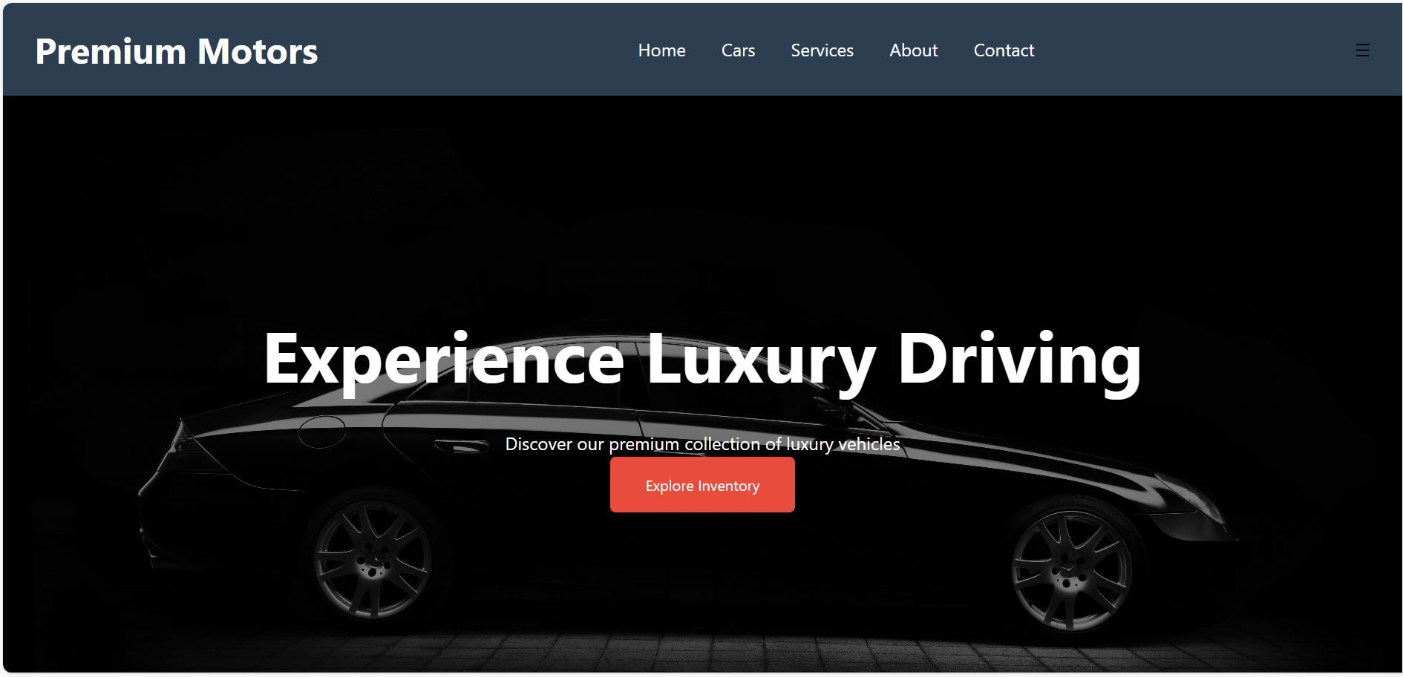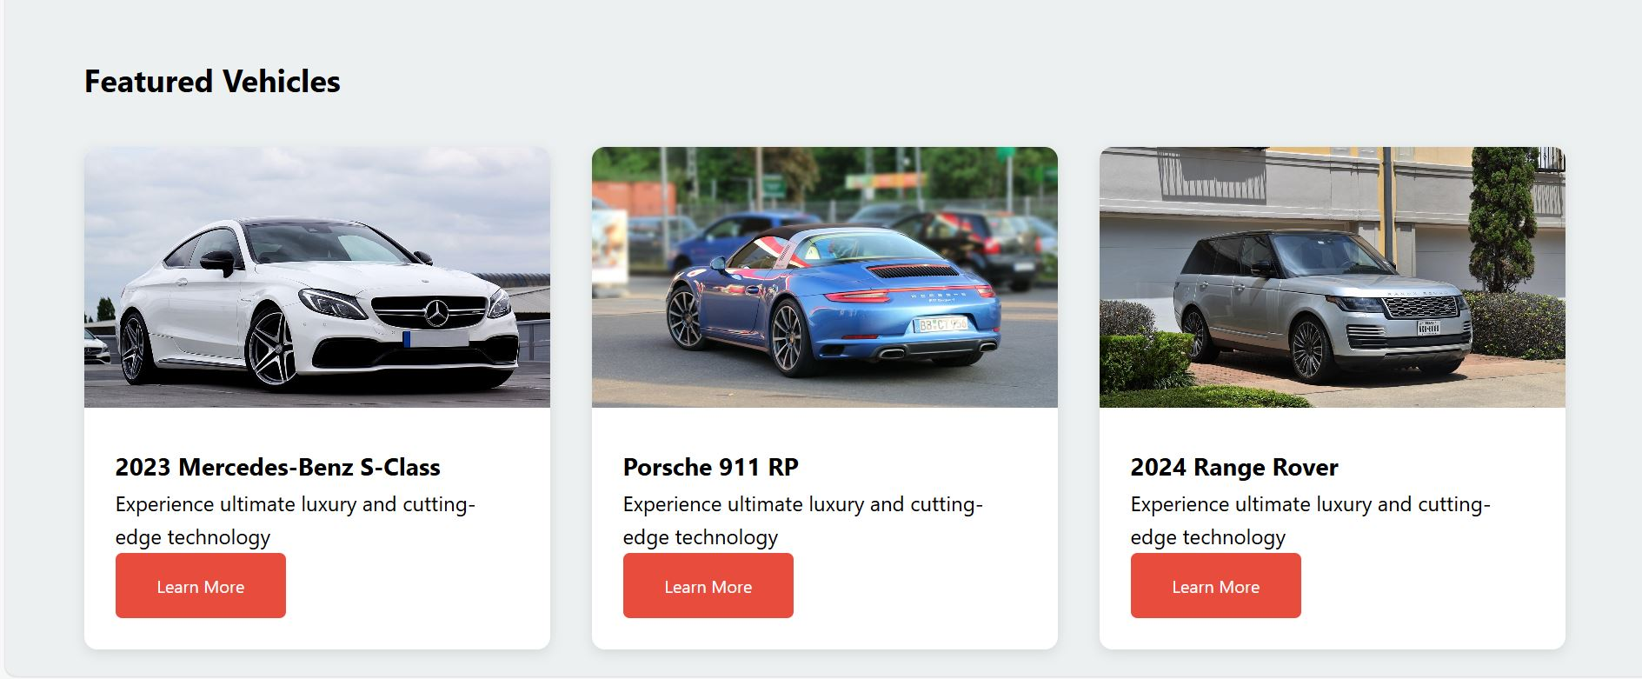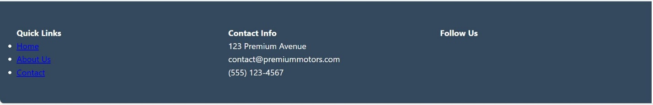

Cars
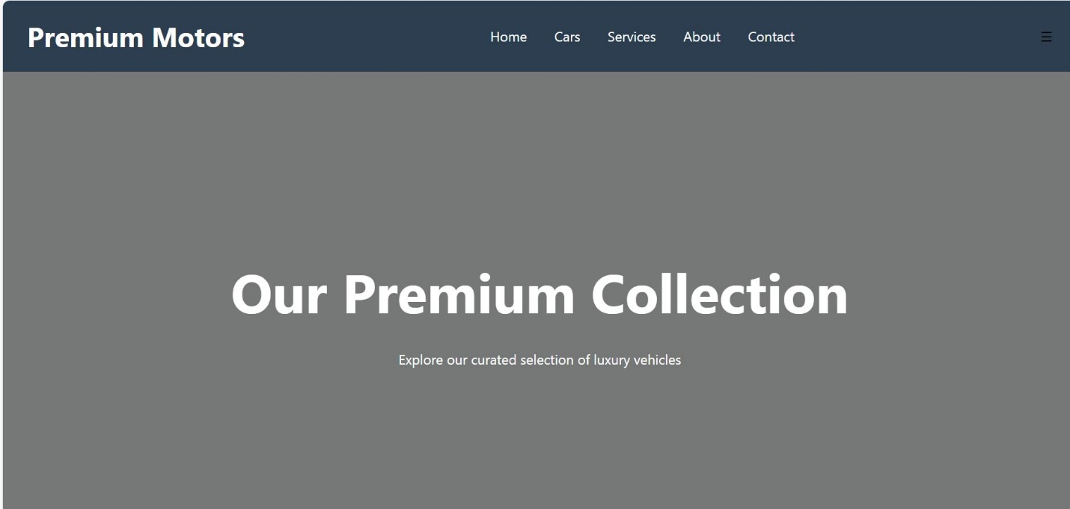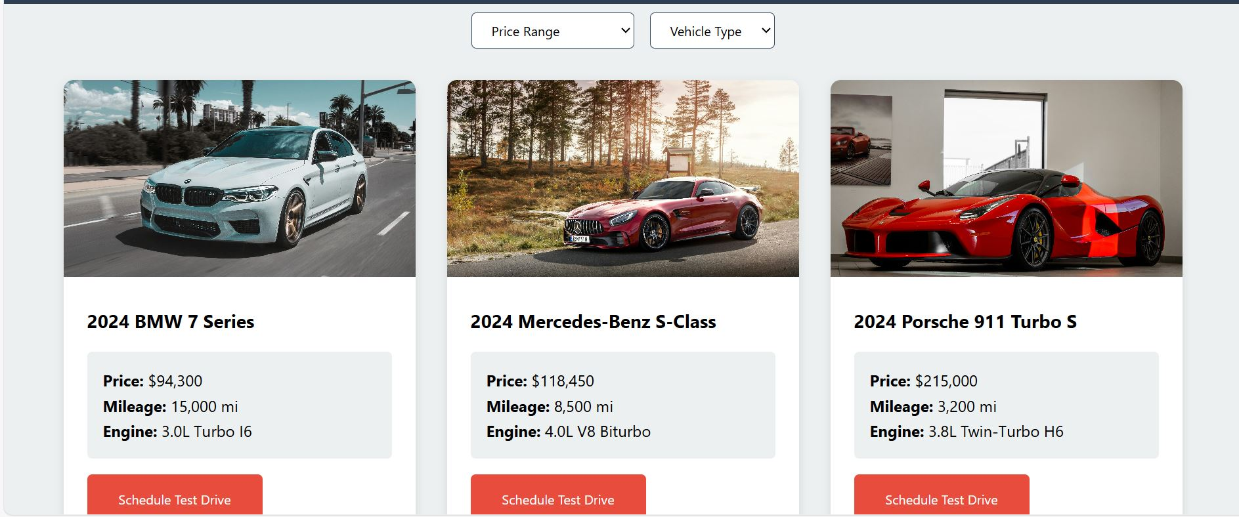

Services

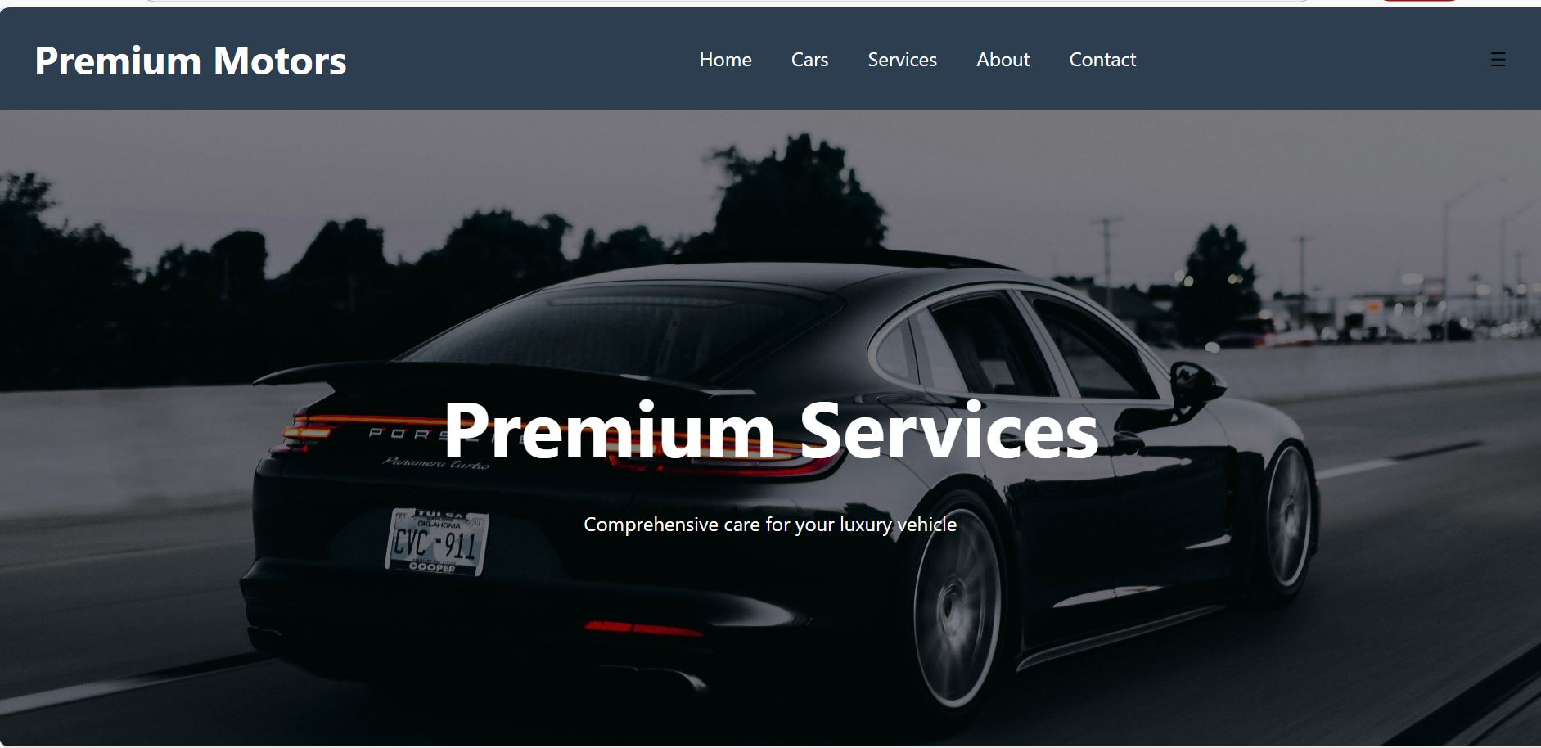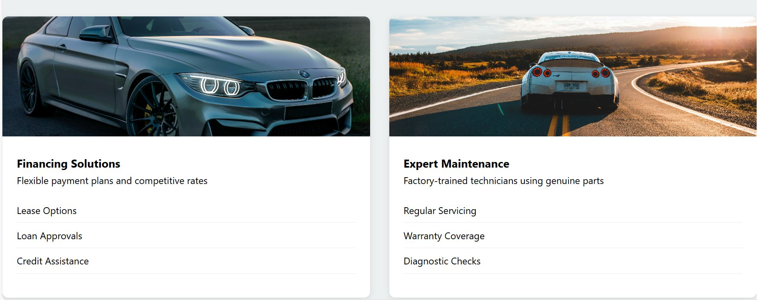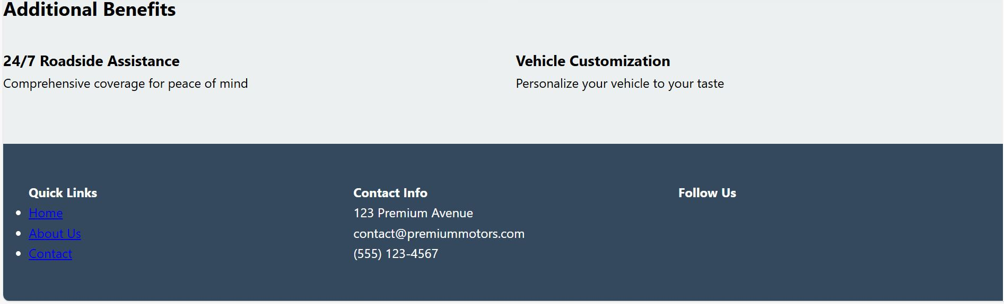

About

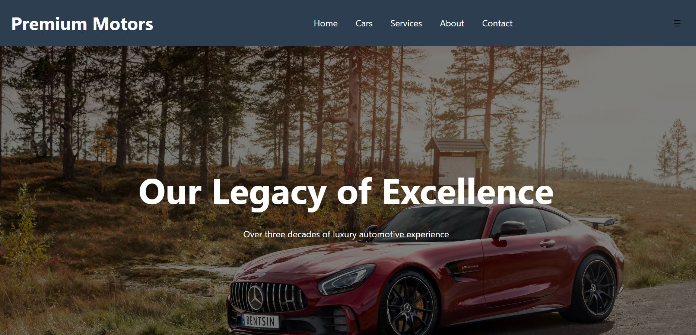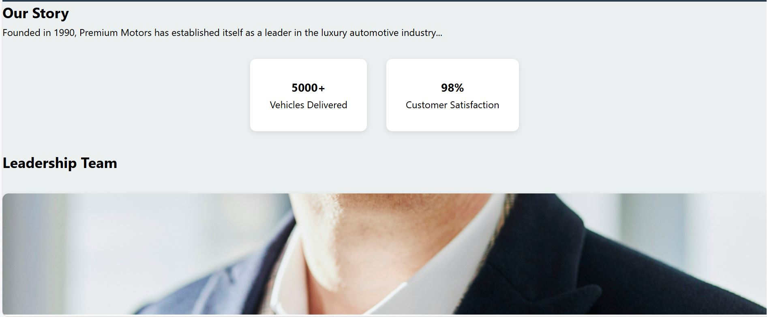

Contact
